Biology: The Core, 3e (Simon)
Chapter 1 An Introduction to the Science of Life

1) How is life defined?
A) The only requirement for life is the ability to reproduce.
B) Life is defined through a set of shared characteristics that all living things display.
C) A living thing must be able to move.
D) Life is determined by neural activity.
Answer: B
Module: 1.1
Skill: Remembering/Understanding
Learning Outcome: 1.1

2) Which of the following is not a characteristic of life?
A) The ability to reproduce
B) The ability to move
C) The ability to grow and develop
D) The ability to respond to the environment
Answer: B
Module: 1.1
Skill: Remembering/Understanding
Learning Outcome: 1.1
Global Learning: G2

3) Fire can move, grow, reproduce, use energy, consume oxygen, and interact with its environment. Why is it not alive?
A) It does not have cells.
B) It does not consist of complex, well-ordered structures.
C) It does not pass on genes for traits to its offspring.
D) All of the above are accurate reasons why fire is not alive.
Answer: D
Module: 1.1
Skill: Applying/Analyzing
Learning Outcome: 1.1
Global Learning: G2

4) Is a virus considered alive?
A) Yes, it possesses all of the requirements for life.
B) Yes, it possesses enough of the requirements for life to be considered living.
C) No, it does not possess all of the requirements for life.
D) No, it does not possess any of the requirements for life.
Answer: C
Module: 1.1
Skill: Applying/Analyzing
Learning Outcome: 1.1

5) Certain parasites, such as intestinal tapeworms, cannot survive outside of their host. Why are they still considered alive?
A) Survival outside of a host is not a requirement for life.
B) Parasites are still considered alive because they are studied by biologists, and biology is the study of life.
C) As long as parasites are made of cells, they are considered to be alive.
D) Because they cannot survive outside of the host, parasites are actually not considered alive.
Answer: A
Module: 1.1
Skill: Synthesizing/Evaluating
Learning Outcome: 1.1
Global Learning: G2

6) A population consists of ________.
A) living and nonliving components
B) interacting populations
C) a group of interacting individuals of one species
D) a group of interacting individuals from different species
Answer: C
Module: 1.2
Skill: Remembering/Understanding
Learning Outcome: 1.2

7) The statement, "There are 628 gray squirrels living on campus," describes the ________ of gray squirrels on campus.
A) species
B) community
C) population
D) ecosystem
Answer: C
Module: 1.2
Skill: Applying/Analyzing
Learning Outcome: 1.2

8) What is the smallest unit of life?
A) An atom
B) A molecule
C) A cell
D) An organism
Answer: C
Module: 1.2
Skill: Remembering/Understanding
Learning Outcome: 1.2
Global Learning: G2

9) If you were to combine all of the ecosystems on the planet, you would obtain the ________.
A) ionosphere
B) troposphere
C) biosphere
D) envirosphere
Answer: C
Module: 1.2
Skill: Remembering/Understanding
Learning Outcome: 1.2

10) A college campus – including the students, birds, trees, sidewalks, and air – makes up one complete ________.
A) community
B) ecosystem
C) population
D) organism
Answer: B
Module: 1.2
Skill: Applying/Analyzing
Learning Outcome: 1.2

11) Skin is sometimes referred to as the largest organ of the body. Why is skin considered to be an organ and not a tissue or some other structure?
A) Skin consists of multiple cell types functioning as a single integrated unit.
B) Skin consists of multiple tissue types that cooperate to perform a specific task.
C) Skin is a vital component of multiple organ systems.
D) Skin consists of a single cell type.
Answer: B
Module: 1.2
Skill: Synthesizing/Evaluating
Learning Outcome: 1.2
Global Learning: G2

12) Which of the following is the correct organizational hierarchy, from largest to smallest, in the hierarchical order of life? (Some levels have been omitted, so you are looking for the correct order.)
A) Community → Ecosystem → Population → Tissue → Organ → Cell → Organelle → Atom
B) Ecosystem → Community → Population → Organ → Tissue → Cell → Molecule → Atom
C) Biosphere → Community → Population → Tissue → Organ → Cell → Atom → Molecule
D) Ecosystem → Population → Community → Organ system → Organ → Cell → Molecule → Atom
Answer: B
Module: 1.2
Skill: Remembering/Understanding
Learning Outcome: 1.2

13) What is the main difference between an ecosystem and a community?
A) A community and an ecosystem are the same thing in eology
B) A community consists of both living organisms and their nonliving environment, while an ecosystem consists of nonliving components only
C) A community consists of living organisms only, while an ecosystem consists of both living organisms and their nonliving environment
D) A community consists of nonliving components, while an ecosystem consists of living organisms
Answer: C
Module: 1.2
Skill: Applying/Analyzing
Learning Outcome: 1.2

14) What is the core theme that unifies all of biology?
A) The theory of evolution by natural selection
B) The flow of information from DNA to proteins
C) The transformation of energy and matter
D) The relationship between structure and function
Answer: A
Module: 1.3
Skill: Applying/Analyzing
Learning Outcome: 1.2

15) Which of the following is/are major themes in the field of biology?
A) The relationship between structure and function
B) The flow of information from DNA to proteins
C) The interconnections within and between levels of biological organization
D) All of the above are major themes in the field of biology
Answer: D
Module: 1.3
Skill: Remembering/Understanding
Learning Outcome: 1.2

16) What is typically the first step in the scientific method?
A) Carrying out an experiment
B) Developing a hypothesis
C) Making a prediction
D) Making an observation
Answer: D
Module: 1.4
Skill: Remembering/Understanding
Learning Outcome: 1.3
Global Learning: G1

17) The scientific method ________.
A) is a linear process that must be precisely followed at all times
B) is a rough recipe for answering questions, but the steps need not always need to be performed in the same order
C) is undertaken only by trained scientists in a controlled laboratory setting
D) is the means by which absolute truth can be uncovered
Answer: B
Module: 1.4
Skill: Applying/Analyzing
Learning Outcome: 1.3
Global Learning: G1

Use the following commercial to answer the question(s) below: A recent commercial advertised for a wristband that claimed to restore health and balance by taking advantage of natural frequencies of your biofield. It supports its claim by showing several people first struggling to balance without the wristband and then balancing fine with the wristband.

18) Why should you be skeptical of the claims made in this commercial?
A) Health cannot be tested via the scientific method.
B) You cannot believe anything you see on television.
C) The study was too objective.
D) It was not a controlled study, but rather an anecdotal evidence.
Answer: D
Module: 1.4, 1.9
Skill: Applying/Analyzing
Learning Outcome: 1.5
Global Learning: G1, G5, G6

19) Which of the following is a potential problem with the information presented?
A) There was a small sample size (only a few people presented).
B) There were no control groups presented.
C) There was no indication that the results were repeated.
D) All of the above are potential problems with the information presented.
Answer: D
Module: 1.9
Skill: Applying/Analyzing
Learning Outcome: 1.5
Global Learning: G1, G5, G6

Use the following study to answer the following question(s): A current trend among professional baseball players is to wear braided titanium necklaces. The titanium reportedly regulates the flow of energy through the body. The player wearing the necklace then shows improved strength, tires less, and recovers more quickly.

20) If you were to evaluate these claims using the scientific method, what would be the first step?
A) Conduct an experiment.
B) Gather testimonials.
C) Develop a hypothesis.
D) Evaluate the results.
Answer: C
Module: 1.4
Skill: Applying/Analyzing
Learning Outcome: 1.3
Global Learning: G1, G2

21) Which of the following would be the strongest evidence for or against the necklace's effectiveness?
A) A bar graph comparing the percentage of players who wear the necklace with the percentage of players who do not wear the necklace
B) A scatter plot showing days on the disabled list and percentage of players who do or do not wear the necklace
C) A bar graph illustrating the satisfaction levels of the players who wear the necklace
D) A bar graph comparing batting averages of the players who wear the official titanium necklace and those who were unknowingly wearing a fake titanium necklace
Answer: D
Module: 1.4, 1.7, 1.9
Skill: Applying/Analyzing
Learning Outcome: 1.3
Global Learning: G1, G3, G4

22) What should one do if the results of an experiment consistently do not support the original hypothesis?
A) Change the hypothesis to match the results.
B) Change the results to match the hypothesis.
C) Accept the original hypothesis.
D) Reject the original hypothesis and formulate a new hypothesis.
Answer: D
Module: 1.4
Skill: Applying/Analyzing
Learning Outcome: 1.3
Global Learning: G1

23) Which of the following statements is correct regarding the process of science?
A) The process of science is all about testing hypotheses.
B) The process of science involves testing hypotheses, but also collecting data.
C) The process of science involves testing hypotheses, but also phases of exploration, communication and societal outcomes.
D) The process of science is all about developing new technologies.
Answer: C
Module: 1.4
Skill: Remembering/Understanding
Learning Outcome: 1.2

24) What does the term theory mean to a scientist?
A) A guess
B) A proposed explanation for an observed phenomenon
C) A hypothesis that has been supported by the evidence of one experiment
D) A hypothesis that has been supported by a large number of experiments
Answer: D
Module: 1.5
Skill: Remembering/Understanding
Learning Outcome: 1.3
Global Learning: G1

25) Evaluate the following statements; which statement is accurate?
A) Scientists use the word theory in the same way that they use the word hypothesis; both mean a general idea that remains to be well tested.
B) Scientists use the word theory to mean a hypothesis that has been supported by many experiments; this is the same way non-scientists use the word theory.
C) Scientists use the word theory to mean a hypothesis that has not been tested many times; this is the same way non-scientists use the word theory.
D) Scientists use the word theory to mean a hypothesis that has been supported by many experiments; non-scientists use the word theory to mean a hypothesis that remains to be well tested.
Answer: D
Module: 1.5
Skill: Applying/Analyzing
Learning Outcome: 1.3
Global Learning: G1

26) Hypotheses must be ________.
A) testable
B) falsifiable
C) repeatable
D) All of the above are important characteristics of hypotheses.
Answer: D
Module: 1.5
Skill: Remembering/Understanding
Learning Outcome: 1.3
Global Learning: G1

Use the following study to answer the following question(s): A researcher applies varying amounts of fertilizer (0, 2, 4, 8, 10 units) to 50 potted tomato plants. All other variables that may affect the outcome (watering, temperature, sunlight, plant size, etc.) are kept the same from pot to pot. At the end of the growing season, the tomatoes grown on each plant are weighed to determine which fertilizer level produced the largest tomato yield.

27) Which variable is the independent variable?
A) The temperature
B) The tomato yield at the end of the growing season
C) The fertilizer amount
D) The plant size at the end of the growing season
Answer: C
Module: 1.6
Skill: Synthesizing/Evaluating
Learning Outcome: 1.4
Global Learning: G1

28) Which variable is the dependent variable?
A) The temperature
B) The tomato yield at the end of the growing season
C) The fertilizer amount
D) The plant size at the end of the growing season
Answer: B
Module: 1.6
Skill: Synthesizing/Evaluating
Learning Outcome: 1.4
Global Learning: G1

29) Is the study presented above a controlled experiment?
A) Yes, because only the amount of fertilizer was changed, everything else was kept the same.
B) Yes, because many pots were used.
C) No, because the experiment was done only once.
D) No, because several different amounts of fertilizers were used, not just one amount.
Answer: A
Module: 1.6
Skill: Applying/Analyzing
Learning Outcome: 1.4

Use the following information to answer the following question(s): You wake up one morning feeling slightly under the weather. A close family member enthusiastically suggests that you take some Echinacea, an herb commonly used as a cold remedy. You then decide to design an experiment to test Echinacea and see if this claim is true. You think, "If taken at the beginning of a cold, Echinacea will reduce cold symptoms."

30) Your statement, "If taken at the beginning of a cold, Echinacea will reduce cold symptoms," is called a(n) ________.
A) observation
B) hypothesis
C) conclusion
D) theory
Answer: B
Module: 1.5
Skill: Applying/Analyzing
Learning Outcome: 1.3, 1.4
Global Learning: G1

31) You decide to test the effects of Echinacea on 100 people who are experiencing similar cold symptoms. Which of the following groups would represent an appropriate control in your experiment?
A) One healthy person given Echinacea tablets
B) One sick person given Echinacea tablets
C) 100 healthy people given tablets similar to Echinacea but with no herb
D) 100 sick people given tablets similar to Echinacea but with no herb
Answer: D
Module: 1.6
Skill: Applying/Analyzing
Learning Outcome: 1.4
Global Learning: G1

32) If you give 100 sick people tablets similar to Echinacea but with no herb (called a placebo), and do not tell them whether they are receiving the placebo or the Echinacea tablet, what kind of control would this be?
A) A positive control, since you are expecting a change to happen in this control group
B) A negative control, since you are expecting no change to happen in this control group
C) A blind control, since the sick people do not know whether they are receiving the placebo or the Echinacea
D) Both B and C are correct
Answer: D
Module: 1.6
Skill: Synthesizing/Evaluating
Learning Outcome: 1.4
Global Learning: G1

33) You conduct the experiment and gather the data presented in the figure below. Given the results, you can say that ________.

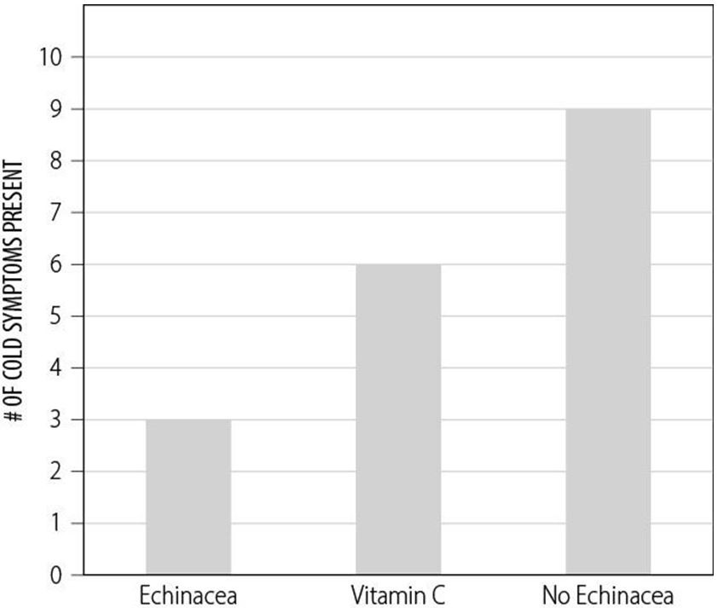

A) your theory is proven
B) your theory is disproven
C) your hypothesis is not supported
D) your hypothesis is supported
Answer: D
Module: 1.6, 1.7, 1.9
Skill: Applying/Analyzing
Learning Outcome: 1.3, 1.4
Global Learning: G1, G3, G9

34) Which of the following represents a double-blind study?
A) The test group knows whether they are receiving a placebo or the actual treatment, and so do the researchers.
B) The test group does not know whether they are receiving a placebo or the actual treatment, but the researchers do.
C) The test group knows whether they are receiving a placebo or the actual treatment, but the researchers do not know until all the data are collected.
D) Neither the test group nor the researchers know whether the test group is receiving a placebo or the actual treatment until all the data are collected.
Answer: D
Module: 1.6, 1.8
Skill: Applying/Analyzing
Learning Outcome: 1.4
Global Learning: G1

35) Which of the following represents a blind study?
A) The test group knows whether they are receiving a placebo or the actual treatment, and so do the researchers.
B) The test group does not know whether they are receiving a placebo or the actual treatment, but the researchers do.
C) The test group knows whether they are receiving a placebo or the actual treatment, but the researchers do not know until all the data are collected.
D) Neither the test group nor the researchers know whether the test group is receiving a placebo or the actual treatment until all the data are collected.
Answer: B
Module: 1.6, 1.8
Skill: Applying/Analyzing
Learning Outcome: 1.4
Global Learning: G1

36) Many medical studies include a control group in which patients receive a medically ineffective treatment that resembles the treatment tested. What do we call the ineffective treatment?
A) The placebo
B) The dependent variable
C) The controlled experiment
D) The hypothesis
Answer: A
Module: 1.6, 1.8
Skill: Remembering/Understanding
Learning Outcome: 1.4
Global Learning: G1, G5

37) Many medical studies show that patients who receive a treatment feel better even if the treatment was an ineffective sugar pill. What is this phenomenon called?
A) The control group
B) The placebo effect
C) The fake effect
D) The blind effect
Answer: B
Module: 1.6
Skill: Remembering/Understanding
Learning Outcome: 1.4
Global Learning: G1, G5

38) Which of the following statements cannot be tested by science?
A) Male lions sleep 20 hours a day.
B) Male lions have brown manes.
C) It is wrong that male lions kill baby lions when taking over a new pride.
D) All statements can be tested by science.
Answer: C
Module: 1.5
Skill: Applying/Analyzing
Learning Outcome: 1.3
Global Learning: G1

39) A well-substantiated explanation of some aspect the natural world, based on a body of facts that have been repeatedly confirmed through observations and experiments, is referred to as a(n) ________.
A) idea
B) hypothesis
C) theory
D) fact
Answer: C
Module: 1.5
Skill: Remembering/Understanding
Learning Outcome: 1.3
Global Learning: G1

40) You want to know whether cookies made with unbleached flour taste better than cookies made with bleached flour; which of the following has the strongest experimental design to test this question?
A) Make two batches of cookies, both with bleached flour; one taster tries both types and ranks which type they like best.
B) Make two batches of cookies, one with bleached flour and one with unbleached flour; one taster tries both types and ranks which type they like best.
C) Make two batches of cookies, one with bleached flour and one with unbleached flour; twenty tasters try both types and rank which type they like best.
D) Make two batches of cookies, one with bleached flour and one with unbleached flour; twenty tasters try both types without knowing which ones they are eating and rank which type they like best.
Answer: D
Module: 1.6
Skill: Synthesizing/Evaluating
Learning Outcome: 1.4
Global Learning: G1, G2

41) What is misleading about commercials that show "scientific proof" that laundry detergent X is better than another leading brand?
A) We are shown only one tee-shirt becoming whiter in each detergent, not 20 tee-shirts in each detergent.
B) We do not know whether the same amount of each detergent was used for washing.
C) We do not know if everything besides the detergents was the same (machine used, type of stains, etc.).
D) All of the above are aspects that are misleading.
Answer: D
Module: 1.9
Skill: Applying/Analyzing
Learning Outcome: 1.5
Global Learning: G1, G5, G6

42) A controlled experiment is one in which ________.
A) there are at least two groups, one differing from the other by two or more variables
B) the experiment is repeated many times to ensure that the results are accurate
C) the experiment proceeds at a slow pace to guarantee that the scientist can carefully observe all reactions and process all experimental data
D) there are at least two groups, one of which does not receive the experimental treatment
Answer: D
Module: 1.6
Skill: Remembering/Understanding
Learning Outcome: 1.4
Global Learning: G1

43) What does it mean when we say, "This scientific study was published in a peer-reviewed journal"?
A) This study can now be viewed on the Internet.
B) This study was published in a newspaper.
C) This study was evaluated by qualified and impartial experts before being published.
D) This study was not evaluated by other scientists.
Answer: C
Module: 1.10
Skill: Applying/Analyzing
Learning Outcome: 1.5
Global Learning: G1, G5, G6

44) What is the difference between a primary and a secondary source?
A) A primary source is the original material published by the scientists, whereas a secondary source is a description of the original material.
B) A primary source is the raw data before scientists publish, whereas a secondary source is a description of the original material.
C) A primary source is the original material published by the scientists, whereas a secondary source is the raw data before scientists publish.
D) There is no difference between primary and secondary sources.
Answer: A
Module: 1.10
Skill: Remembering/Understanding
Learning Outcome: 1.5
Global Learning: G1, G5, G6

Use the following table to answer the following question(s).

Table 1: Cookie parameters with varying fat levels

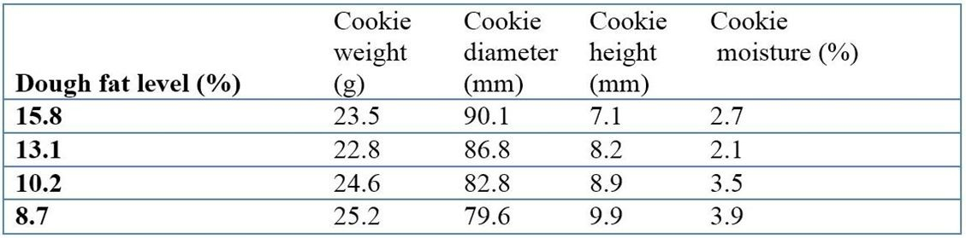

Data from Pareyt, Bram, Faisal Talhaoui, Greet Kerckhofs, Kristof Brijs, Hans Goesaert, Martine Wevers, and Jan A. Delcour, "The Role of Sugar and Fat in Sugar-Snap Cookies: Structural and Textural Properties." Journal of Food Engineering 90, 3 (Feb. 1, 2009): 400-408.

45) Based on the table above, which type of cookie was the heaviest?
A) The cookies with the most fat
B) The cookies with intermediate amount of fat
C) The cookies with the least fat
D) The amount of fat did not affect the weight of cookies
Answer: A
Module: 1.6, 1.7
Skill: Applying/Analyzing
Learning Outcome: 1.4
Global Learning: G3, G4

46) Based on the table above, which cookies were the moistest?
A) The cookies with the most fat
B) The cookies with intermediate amount of fat
C) The cookies with the least fat
D) All cookies had the same moisture
Answer: C
Module: 1.6, 1.7
Skill: Applying/Analyzing
Learning Outcome: 1.4
Global Learning: G3, G4

47) Based on the table above, which of the following statements is not correct?
A) Cookies with the most fat were the cookies that were not only the flattest but also the largest in diameter.
B) Cookies with the most fat were the cookies that were not only the flattest but also the driest with the least moisture.
C) Cookies with the most fat were the cookies that were not only the thickest but also the largest in diameter.
D) Cookies with the least fat were not only the heaviest but also the thickest cookies.
Answer: C
Module: 1.6
Skill: Synthesizing/Evaluating
Learning Outcome: 1.4
Global Learning: G3, G4

48) Based on the table above, which of the following statements is correct?
A) The amount of fat and sugar in the cookies affects not only the cookies' weight and size but also their moisture.
B) The amount of fat in the cookies affects not only the cookies' weight and size but also their moisture. The effects of sugar on the cookies are unknown.
C) The amount of sugar in the cookies affects not only the cookies' weight and size but also their moisture. The effects of far on the cookies are unknown.
D) Fat and sugar do not affect the cookies' weight, size, and moisture.
Answer: B
Module: 1.6, 1.7
Skill: Synthesizing/Evaluating
Learning Outcome: 1.4
Global Learning: G3, G4

49) To obtain large, flat cookies, one should use more fat in a recipe.
Answer: TRUE
Module: 1.6, 1.7
Skill: Applying/Analyzing
Learning Outcome: 1.4
Global Learning: G3, G4

Use the following graph to answer the following question(s).

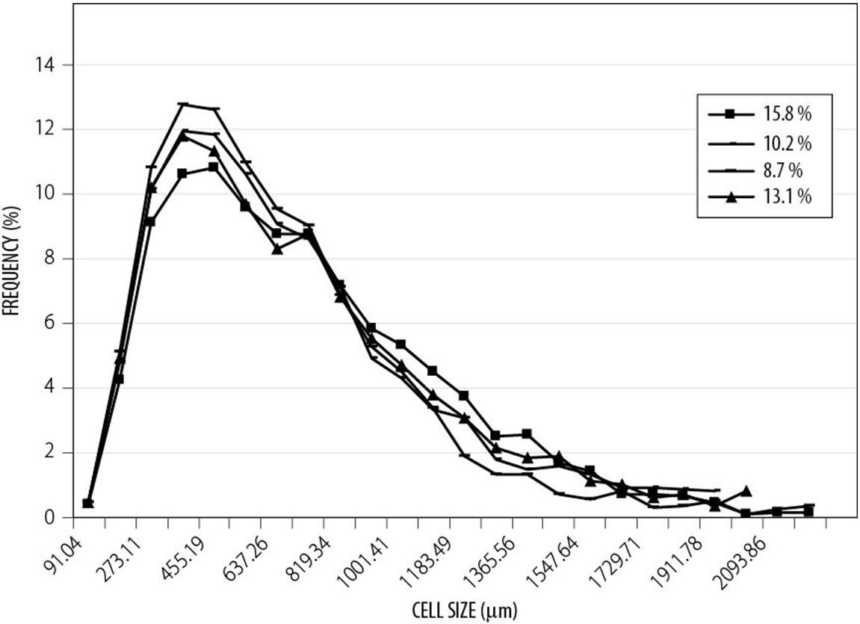

50) Regardless of the amount of fat contained in cookies, the most common cell size in a cookie was ________.
A) very large (larger than 1,500 μm)
B) very small (smaller than 100 μm)
C) between 280 and 500 μm
D) between 1,000 and 15,000 μm
Answer: C
Module: 1.6, 1.7
Skill: Synthesizing/Evaluating
Learning Outcome: 1.4
Global Learning: G3, G4

51) What type of graph is this?
A) A bar graph
B) A pie chart
C) A scatter plot
D) A table
Answer: C
Module: 1.6, 1.7
Skill: Remembering/Understanding
Learning Outcome: 1.4

52) The cookies with the least amount of fat had more cells around 500 μm in size than did the cookies with the most amount of fat.
Answer: TRUE
Module: 1.6, 1.7
Skill: Applying/Analyzing
Learning Outcome: 1.4
Global Learning: G3, G4

53) The amount of fat does not affect the frequency of the size of cells found in cookies.
Answer: FALSE
Module: 1.6, 1.7
Skill: Applying/Analyzing
Learning Outcome: 1.4
Global Learning: G3, G4

54) How can you recognize a reliable source of information?
A) By checking whether the authors are well qualified
B) By checking whether the source of information is primary
C) By checking whether the information was peer-reviewed
D) All of the above are ways to check whether a source is reliable
Answer: D
Module: 1.10
Skill: Remembering/Understanding
Learning Outcome: 1.5
Global Learning: G6

55) Name at least three organs that are part of your digestive system. Explain why the organs you chose are in fact organs and not something else. Describe their role in the digestive system.
Answer: Stomach (chemical digestion), small intestine (nutrient absorption), large intestine (water reabsorption), liver (bile production), gallbladder (bile storage), pancreas (digestive enzyme production). These organs all consist of multiple tissue types that cooperate to perform a specific task.
Module: 1.2
Skill: Synthesizing/Evaluating
Learning Outcome: 1.1
Global Learning: G7

56) The scientific method has limitations. It can only answer objective questions based on quantitative facts from observable, measurable, and repeatable experiments. It cannot answer subjective questions based on qualitative beliefs or opinions such as the presence of deities and ghosts or who makes the best doughnut. Could the scientific method theoretically be used to answer the question, "Does throwing a virgin into a volcano prevent it from erupting?" Support your answer.
Answer: While unethical, after defining a few terms, a controlled experiment could be designed to test this hypothesis. It may require multiple virgins and/or multiple volcanoes, but it would be possible to discover whether a correlation exists.
Module: 1.6
Skill: Synthesizing/Evaluating
Learning Outcome: 1.3
Global Learning: G1, G2

57) In science, experiments are widely used. Are experiments better than observational studies? Discuss the merits and shortcomings of both types of studies.
Answer: Both experimental and observational studies have their place in science, and one is not better than the other. Instead, each method brings its own strengths and weaknesses, and each one is best used in a specific context. Observational studies involve the observation of the natural world without any manipulation; they are most useful when scientists cannot ethically carry out an experiment (on human health, or on an ecosystem for instance), and can generate important knowledge about how the world works. As such, observational studies provide highly realistic knowledge. One drawback of observational studies is that, since there is no manipulation, there is no causal relationships that can be determined. Experimental studies involve the manipulation of one or more variables; they are most useful in determining a cause-and-effect relationship. They are less realistic than observational studies, and can sometimes generate artificial results that would not occur in the natural world.
Module: 1.8
Skill: Synthesizing/Evaluating
Learning Outcome: 1.3
Global Learning: G1, G2

